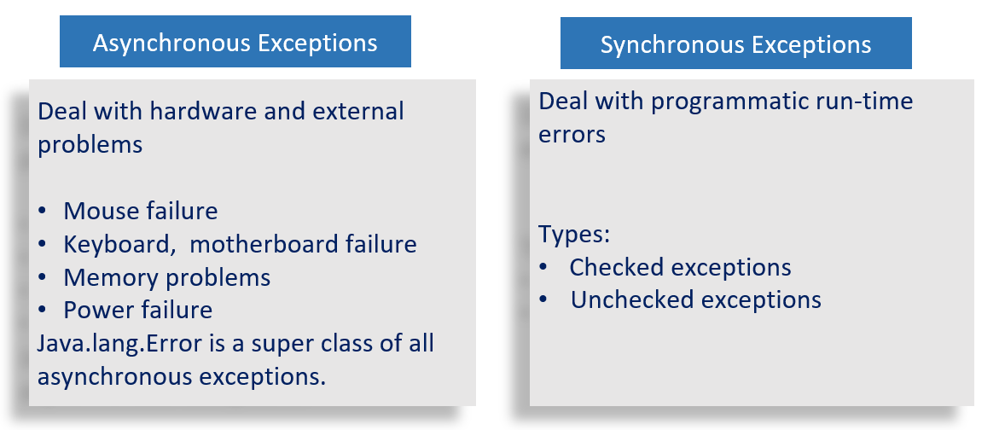

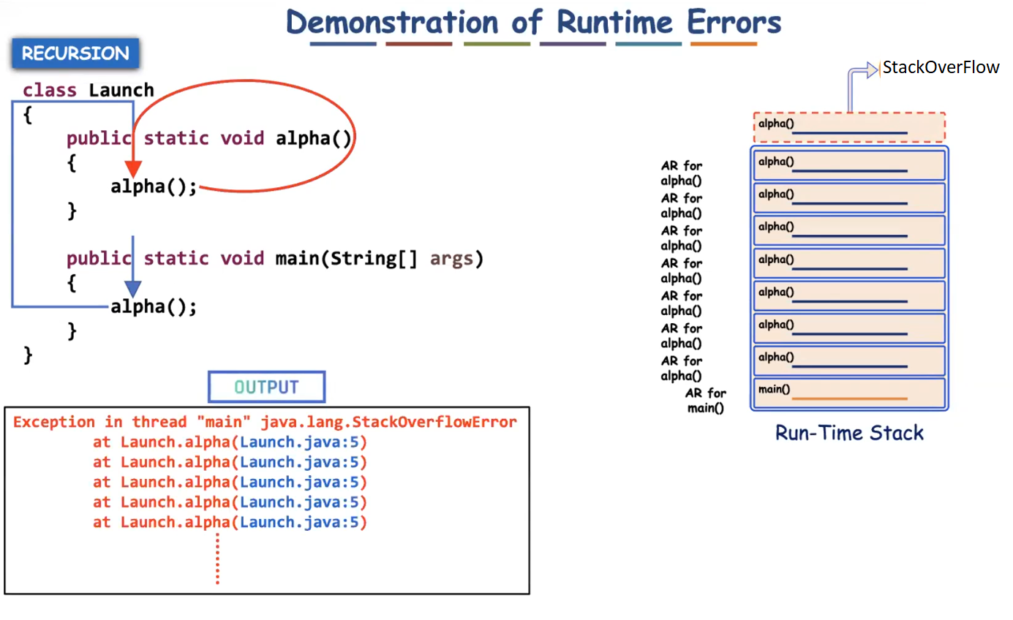

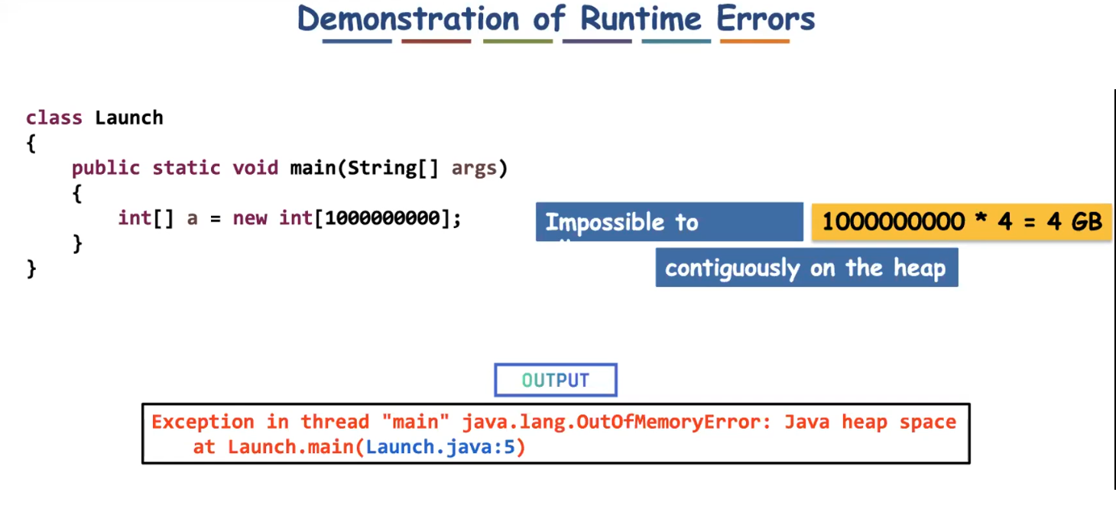

✅ Can if-else Avoid Exception Handling?
No.
if-else cannot replace exception handling.
They are used for different purposes.

✅ What is if-else Used For?
if-else is used for:
- Validating normal conditions
- Handling expected situations
- Making decisions in business logic
Example:
if (balance >= amount) {
withdraw();
} else {
System.out.println("Insufficient balance");
}
This is normal program logic.

✅ What is Exception Handling Used For?
Exception handling is used for:
- Handling unexpected runtime problems
- Handling system-level failures
- Separating error handling from normal logic
- Propagating errors to the caller
Examples:
- File not found
- Database connection failure
- Network timeout
- Null pointer access
- Division by zero

- if-else does not automatically propagate errors.
Exception handling supports propagation through throw and throws.
- Example:
- void withdraw(int amount) throws InsufficientBalanceException {
if (balance < amount) {
throw new InsufficientBalanceException("Not enough balance");
}
}
- Now the caller must handle it.
- This is called exception propagation.

✅ Can if-else Avoid Exception Handling?
No.
if-else cannot replace exception handling.
They are used for different purposes.

✅ What is if-else Used For?
if-else is used for:
- Validating normal conditions
- Handling expected situations
- Making decisions in business logic
Example:
if (balance >= amount) {
withdraw();
} else {
System.out.println("Insufficient balance");
}
This is normal program logic.

✅ What is Exception Handling Used For?
Exception handling is used for:
- Handling unexpected runtime problems
- Handling system-level failures
- Separating error handling from normal logic
- Propagating errors to the caller
Examples:
- File not found
- Database connection failure
- Network timeout
- Null pointer access
- Division by zero

✅ Important Correction About Propagation
You said:
If-else can’t propagate the problem to the caller.
More accurately:
if-else does not automatically propagate errors.
Exception handling supports propagation through throw and throws.
Example:
void withdraw(int amount) throws InsufficientBalanceException {
if (balance < amount) {
throw new InsufficientBalanceException("Not enough balance");
}
}
Now the caller must handle it.
This is called exception propagation.

✅ ATM Example (Refined and Clear)
ATM scenario:
- User enters PIN.
- If PIN is wrong → ATM asks to re-enter.
- After 3 wrong attempts → account gets blocked.
- Blocking information is updated in bank server.
- Even other ATMs cannot access the account.
Now how does this relate?
- Checking PIN format → normal if-else.
- Blocking account after 3 failures → business rule.
- Server update failure, database failure → exception handling.
Wrong PIN itself is not always an exception.
It is usually treated as validation failure.
System failure (like server crash) is an exception.

✅ Very Important Difference
if-else | Exception Handling
Handles expected conditions | Handles unexpected problems
Part of business logic | Separates error logic
No built-in propagation | Supports propagation
Makes code cluttered if overused | Cleaner structured error handling
Does not force handling | Compiler can force handling (checked exceptions)

✅ Why if-else Cannot Replace Exception Handling
- It cannot handle system-level failures.
- It does not separate normal flow from error flow.
- It cannot enforce compile-time checking.
- It does not provide stack trace information.
- It cannot propagate errors automatically.
- It makes code complex if used for every error case.

✅ When to Use What?
Use if-else for:
- Input validation
- Business rules
- Normal conditions
Use exception handling for:
- Technical failures
- Unexpected runtime errors
- Resource failures
- System issues

✅ Final Self-Explanatory Statement
if-else is used to handle expected conditions in program logic.
Exception handling is used to handle unexpected runtime problems and to propagate errors to higher levels of the application.
Therefore, if-else cannot replace exception handling because both serve different purposes.

✅ What is a Custom Defined Exception?
A custom exception is:
An exception class created by the programmer to represent a specific business problem.
Java already gives many exceptions like:
- NullPointerException
- IOException
- ArithmeticException
But in real projects, we create our own.
Example:
- InsufficientBalanceException
- InvalidPinException
- UserNotFoundException

✅ Why Do We Need Custom Exceptions?
Because:
- Built-in exceptions are too generic.
- Business logic needs meaningful error names.
- Code becomes more readable.
- Error handling becomes clean and structured.
Example:
Instead of writing:
throw new Exception("Error");
Better:
throw new InsufficientBalanceException("Not enough balance");
Now the error clearly explains the problem.

✅ Rules to Create Custom Exception
There are 2 types:
1️⃣ Checked Custom Exception
2️⃣ Unchecked Custom Exception

🔹 1️⃣ Rule to Create Checked Custom Exception
If you want it to be checked, extend:
Exception
Syntax:
class MyException extends Exception {
public MyException(String message) {
super(message);
}
}
Important Rules:
- Must extend Exception
- Constructor should call super(message)
- Must handle or declare using throws

Example: Checked Custom Exception
class InsufficientBalanceException extends Exception {
public InsufficientBalanceException(String message) {
super(message);
}
}
Now use it:
class Bank {
void withdraw(int balance, int amount) throws InsufficientBalanceException {
if (balance < amount) {
throw new InsufficientBalanceException("Balance is low");
}
System.out.println("Withdrawal successful");
}
public static void main(String[] args) {
Bank b = new Bank();
try {
b.withdraw(1000, 2000);
}
catch (InsufficientBalanceException e) {
System.out.println(e.getMessage());
}
}
}
Since it is checked → must handle or declare.

Eg: Custom_Checked_Exception

🔹 2️⃣ Rule to Create Unchecked Custom Exception
If you want it to be unchecked, extend:
RuntimeException
Syntax:
class MyException extends RuntimeException {
public MyException(String message) {
super(message);
}
}
No need to declare with throws.

Example: Unchecked Custom Exception
class InvalidPinException extends RuntimeException {
public InvalidPinException(String message) {
super(message);
}
}
Usage:
class ATM {
void checkPin(int pin) {
if (pin != 1234) {
throw new InvalidPinException("Wrong PIN");
}
System.out.println("Access granted");
}
public static void main(String[] args) {
ATM atm = new ATM();
atm.checkPin(1111); // No try-catch required
}
}
Compiler will not force handling.

Eg: Custom_Unchecked_Exception

✅ Complete Rules Summary
Rule 1
Custom exception class must extend either:
- Exception (for checked)
- RuntimeException (for unchecked)

Rule 2
Always provide constructor with message.
public MyException(String message) {
super(message);
}

Rule 3
Use meaningful class names.
Example:
- InvalidAgeException
- PaymentFailedException
- OrderNotFoundException
Avoid:
- MyException
- TestException

Rule 4
Throw using throw keyword.
throw new MyException("Error message");

Rule 5
Checked custom exceptions must be:
- Handled using try-catch
OR
- Declared using throws

Rule 6
Unchecked custom exceptions do not require mandatory handling.

✅ When to Use Checked vs Unchecked?
Use Checked When:
- Caller must handle the situation
- Recovery is possible
- Business rule enforcement needed
Use Unchecked When:
- Programming mistake
- Invalid input
- Logic error
- You don’t want forced handling

✅ Real Project Usage (Spring Boot Example)
In real applications:
Service layer:
if(user == null) {
throw new UserNotFoundException("User not found");
}
Global exception handler catches it and sends proper response.
Very clean architecture.

✅ Interview Ready Explanation
A custom exception is a user-defined exception class created by extending Exception or RuntimeException to represent application-specific errors. Checked custom exceptions must be handled or declared, while unchecked custom exceptions do not require mandatory handling.

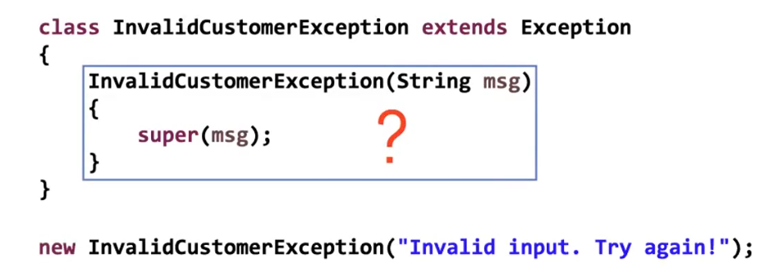

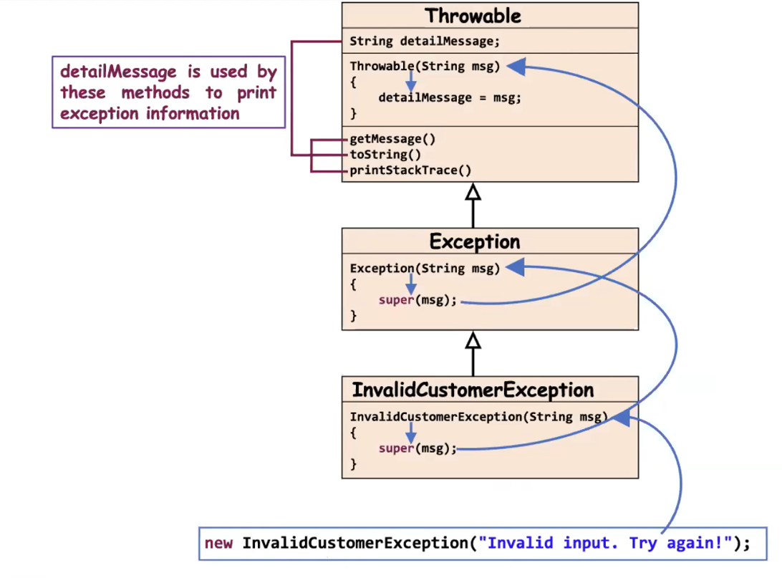

Eg: Exceptional_Handling_Eg9
🔥 What Actually Happens Internally
Step 1
Class is loaded by JVM.
Step 2
Static variables are initialized first.
static int[] a;
Since not initialized:
a = null;

Step 3
Static block runs automatically.
a[0] = 2;
But a is null.
So JVM throws:
NullPointerException

Step 4
Since exception happens inside static block:
JVM wraps it inside:
ExceptionInInitializerError

🔥 Final Output
You will see something like:
Exception in thread "main" java.lang.ExceptionInInitializerError
Caused by: java.lang.NullPointerException

🎯 Very Important Concept
When an exception occurs inside:
- Static block
- Static variable initialization
JVM throws:
ExceptionInInitializerError
Not just NullPointerException.

🧠 Why main() Does Not Execute?
Because:
- Class initialization fails
- Class loading stops
- main() never runs

✅ How to Fix It
Initialize array properly:
static int[] a = new int[5];
Now no exception.

Eg: Exceptional_Handling_Eg10
// go through the code

Eg: Exceptional_Handling_Eg11
// go through the code

When overriding a method, the child method:
- Can throw the same checked exception
- Can throw a subclass of that checked exception
- Can throw no exception
- Cannot throw a broader (parent) checked exception
And yes — even if you use the throw keyword inside the method body, you still cannot throw a broader checked exception than what the parent method allows.
The restriction comes from the method signature (throws clause) and overriding rules, not from the throw keyword itself.

Example (Valid)
Parent:
public void m1() throws IOException
Child (valid):
public void m1() throws IOException {
throw new FileNotFoundException(); // subclass of IOException
}

Example (Invalid)
Parent:
public void m1() throws IOException
Child (invalid):
public void m1() throws IOException {
throw new Exception(); // broader than IOException ❌
}
This causes compilation error because Exception is broader than IOException.

✅ 1️⃣ Is there any rule for Runtime (Unchecked) exceptions in overriding?
✔ No restriction like checked exceptions.
✔ Compiler does NOT enforce any rule.
✔ Handling (try-catch) is optional.
✔ Declaring with throws is optional.
So yes — no strict overriding rule for RuntimeException.
🧠 Important Insight
For checked exceptions, this would be illegal:
Parent throws FileNotFoundException
Child throws IOException (broader) ❌ Not allowed
But for unchecked exceptions:
Parent throws NullPointerException
Child throws RuntimeException ✔ Allowed
Because unchecked exceptions are not checked by compiler during overriding.

Eg: Exception_Handling_Eg12
// go through the code

try {
int x = Integer.parseInt("two");
}

🔍 What Happens Here?
Integer.parseInt("two");
- "two" is not a valid number.
- So parseInt() throws:
👉 NumberFormatException

✅ Which catch blocks are valid?
Now remember one important thing:
NumberFormatException extends IllegalArgumentException
Hierarchy:
Object
↳ Throwable
↳ Exception
↳ RuntimeException
↳ IllegalArgumentException
↳ NumberFormatException

✅ Correct Answers
✔ C. NumberFormatException
Exact exception thrown.
catch (NumberFormatException e)

✔ D. IllegalArgumentException
Because it is the parent class of NumberFormatException.
catch (IllegalArgumentException e)

❌ Why Others Are Wrong?
- A. ClassCastException → Not related
- B. IllegalStateException → Not thrown here
- E. ExceptionInInitializerError → Different category (Error)
- F. ArrayIndexOutOfBoundsException → Not involved
Integer.parseInt() returns a primitive int, not an Integer object.
So:
- No boxing
- No unboxing
It directly returns int.

✅ Final Answer
✔ C
✔ D

✅ ClassCastException
Occurs when an object is cast to a type that is not compatible with its actual runtime type.
It happens at runtime when the cast is invalid.

✅ IllegalStateException
Occurs when a method is invoked at an inappropriate time or when the object is not in the correct state to perform the requested operation.
Example: Calling start() on a thread that has already been started.

✅ NumberFormatException
Occurs when a method that converts a String to a numeric type (like Integer.parseInt()) receives a string that is not in a valid numeric format.

✅ IllegalArgumentException
Occurs when a method receives an argument that is valid in type but inappropriate or invalid in value.
Example: Passing an out-of-range value to a method.

✅ ExceptionInInitializerError
Occurs when an exception is thrown during the execution of a static initializer block or static variable initialization.
It is an Error, not an Exception.

Eg: Exceptional_Handling_Eg13
// go through the code

✅ Given Classes (Exception Hierarchy)
// Parent checked exception
class SubException extends Exception { }
// Child checked exception
class SubSubException extends SubException { }
Hierarchy:
Exception
↑
SubException
↑
SubSubException

✅ Parent Class
public class CC {
void doStuff() throws SubException {
// Parent method throws SubException
}
}

✅ Case 1: Valid Overriding (Child throws narrower exception)
class CC2 extends CC {
void doStuff() throws SubSubException {
// ✔ Valid
// Child is throwing a subclass (narrower exception)
// This is allowed in overriding
}
}
🔎 Why Valid?
- Parent throws SubException
- Child throws SubSubException
- Child exception is smaller/narrower
- This follows overriding rule for checked exceptions

❌ Case 2: Invalid Overriding (Child throws broader exception)
class CC3 extends CC {
void doStuff() throws Exception {
// ❌ Compile-time Error
// Child is throwing broader exception than parent
}
}
🔎 Why Error?
- Parent throws SubException
- Child throws Exception
- Exception is parent of SubException
- Child cannot widen checked exception
- Violates overriding rule
Rule:
Child method cannot throw broader checked exception than parent method.

✅ Case 3: Overloading (Not Overriding)
class CC4 extends CC {
void doStuff(int x) throws Exception {
// ✔ No problem
// This is NOT overriding
// Method signature is different (has parameter)
// So this is overloading
}
}
🔎 Why No Problem?
- Method signature changed
- It is overloading
- Overloading has no exception restriction

✅ Case 4: Child Throws Nothing
class CC5 extends CC {
void doStuff() {
// ✔ Valid
// Child method does not throw any exception
// Narrower than parent
}
}
🔎 Why Valid?
- Parent throws SubException
- Child throws nothing
- Narrower behavior
- Allowed

🔥 Final Overriding Rule for Checked Exceptions
If parent method throws checked exception:
Child method can:
✔ Throw same exception
✔ Throw subclass (narrower)
✔ Throw nothing
Child method cannot:
❌ Throw broader exception
❌ Throw new unrelated checked exception

🎯 Simple Memory Trick
Think like this:
Parent promises:
"I may throw SubException."
Child cannot say:
"I may throw something bigger than that."
Because caller is only prepared to handle SubException.

Eg: Exceptional_Handling_Eg14
// go through the code

Eg: Exceptional_Handling_Eg15
//go through the code

public class Frisbee {
// insert code here
int x = 0;
System.out.println(7/x);
}
Inside main(), we have:
int x = 0;
System.out.println(7/x);

🔥 What Happens at Runtime?
7 / 0
This causes:
ArithmeticException
Important:
✔ ArithmeticException is a subclass of RuntimeException
✔ RuntimeException is unchecked
✔ Compiler does NOT force handling

✅ Now Let’s Analyze Each Main Fragment

I.
public static void main(String[] args) {
✔ Compiles
✔ At runtime → 7/0 → ArithmeticException

II.
public static void main(String[] args) throws Exception {
✔ Compiles
✔ Even though ArithmeticException is unchecked
✔ Runtime → ArithmeticException

III.
public static void main(String[] args) throws IOException {
❌ Does NOT compile
Why?
- IOException is checked.
- But no checked exception is thrown inside main.
- Declaring throws IOException without possible checked exception causes compile error.

IV.
public static void main(String[] args) throws RuntimeException {
✔ Compiles
✔ Runtime → ArithmeticException
Because:
- ArithmeticException is subclass of RuntimeException.
- Runtime exceptions need not be declared.

✅ So Which Compile?
✔ I
✔ II
✔ IV
❌ III

🔥 Runtime Behavior
For I, II, IV:
Program runs → throws:
ArithmeticException

✅ Given Structure
class MyException extends Exception { }
// Checked exception
class Tire {
void doStuff() { }
// Parent method does NOT throw any exception
}
public class Retread extends Tire {
public static void main(String[] args) {
new Retread().doStuff();
}
// insert code here
System.out.println(7/0);
// ArithmeticException (unchecked)
}
Important points:
- MyException → Checked
- ArithmeticException → Unchecked
- Parent method doStuff() → throws nothing

🔥 Very Important Overriding Rule
If parent method does NOT declare any checked exception:
👉 Child method CANNOT declare a new checked exception.
But:
✔ Child CAN declare unchecked exceptions freely.

✅ Now Analyze Each Fragment

I.
void doStuff() {
✔ Valid overriding
✔ No exception declared
✔ Compiles
Runtime:
7/0 → ArithmeticException (unchecked)
✔ Compiles
✔ Runs
✔ Throws ArithmeticException

II.
void doStuff() throws MyException {
❌ Compile-time error
Why?
- MyException is checked.
- Parent method does NOT declare it.
- Child cannot introduce new checked exception.
- Violates overriding rule.

III.
void doStuff() throws RuntimeException {
✔ Valid
Why?
- RuntimeException is unchecked.
- No restriction for unchecked exceptions.
- Child can freely declare it.
Runtime → ArithmeticException
✔ Compiles
✔ Runs
✔ Throws ArithmeticException

IV.
void doStuff() throws ArithmeticException {
✔ Valid
Why?
- ArithmeticException is unchecked.
- Allowed even if parent does not declare anything.
Runtime → ArithmeticException
✔ Compiles
✔ Runs
✔ Throws ArithmeticException

Eg: Exception_Eg16
// go through the code

Eg: Exception_Eg17
// go through the code

✅ Question
Which of the following is a checked Exception?

A. ClassCastException
// ClassCastException
// It is a subclass of RuntimeException
// RuntimeException is unchecked
// So this is NOT a checked exception
Hierarchy:
RuntimeException
↑
ClassCastException
❌ Not checked

B. FileNotFoundException
// FileNotFoundException
// It is a subclass of IOException
// IOException is a checked exception
// So this IS a checked exception
Hierarchy:
Exception
↑
IOException
↑
FileNotFoundException
✔ Checked exception

C. ExceptionInInitializerError
// ExceptionInInitializerError
// It is a subclass of Error
// Error is NOT an Exception
// Errors are unchecked but serious JVM problems
Hierarchy:
Throwable
├── Exception
└── Error
↑
ExceptionInInitializerError
❌ Not checked
Also ❗ It is NOT RuntimeException (important correction)

D. RuntimeException
// RuntimeException
// Parent of all unchecked exceptions
// It itself is unchecked
❌ Not checked

✅ Correct Answer:
✔ B. FileNotFoundException

🔥 Question
Which keyword is used to manually throw an exception?

A. throw
// Used inside method body
// Used to create and throw exception object manually
throw new Exception();
✔ Correct

B. thrown
// Not a Java keyword
❌ Incorrect

C. throws
// Used in method declaration
// Used to declare that method may throw exception
void m1() throws Exception
❌ Does not throw manually

D. catch
// Used to handle exception
// Not used to throw exception
❌ Incorrect

✅ Correct Answer:
✔ A. throw

public class Test {

private static String s;
// Step 1:
// s is declared but NOT initialized.
// Default value of String (reference type) is null.

public static void main(String[] args) {

try {

// Step 2:
// s is null.
// Calling s.length() will cause NullPointerException.
System.out.println(s.length());

}
catch (NullPointerException | RuntimeException ex) {
// ❌ COMPILE-TIME ERROR

/*
Why compilation error?

Because in multi-catch, the exception types
must NOT have parent-child relationship.

Here:

RuntimeException
↑
NullPointerException

NullPointerException is a subclass of RuntimeException.

Since they are related (child-parent),
Java does not allow them in the same multi-catch block.

Compiler error:
"Alternatives in a multi-catch statement cannot be related by subclassing"
*/

System.out.println("DONE");
}
}
}

✅ What Is Multi-Catch?
Java 7 introduced multi-catch:
catch (ExceptionType1 | ExceptionType2 e)
It allows one catch block to handle multiple exception types.

🔥 Core Rule of Multi-Catch
In a multi-catch block, the exception types must NOT have a parent-child relationship.
Meaning:
❌ You cannot combine a superclass and its subclass in the same multi-catch.

❓ Why Is This Rule There?
Because of inheritance and redundancy.
Let’s understand step by step.

🔎 Example of Illegal Multi-Catch
catch (NullPointerException | RuntimeException e)
Hierarchy:
RuntimeException
↑
NullPointerException
Here:
- NullPointerException IS-A RuntimeException
- So catching RuntimeException already covers NullPointerException
So Java says:
“Why are you listing both? One already covers the other.”
Compiler error:
Alternatives in a multi-catch statement cannot be related by subclassing

🧠 Deep Concept Behind It
When an exception occurs, Java checks catch blocks from top to bottom.
In multi-catch:
catch (A | B e)
Java internally treats it like:
if (exception instanceof A OR exception instanceof B)
Now imagine:
catch (NullPointerException | RuntimeException e)
If a NullPointerException occurs:
- It is already a RuntimeException
- So mentioning both is logically unnecessary
- One of them becomes redundant
Java does not allow redundant alternatives in multi-catch.

✅ Legal Multi-Catch Example
catch (IOException | SQLException e)
Hierarchy:
Exception
├── IOException
└── SQLException
Here:
✔ They are siblings
✔ No parent-child relationship
✔ Valid multi-catch

❌ Illegal Example (Parent + Child)
catch (IOException | FileNotFoundException e)
Hierarchy:
IOException
↑
FileNotFoundException
❌ Not allowed
Because FileNotFoundException is already covered by IOException.

🔥 Important Difference
Multi-Catch Rule:
Parent-child not allowed in SAME catch.

Normal Catch Blocks:
Parent-child allowed, BUT:
✔ Child must come first
✔ Parent must come later
Example:
catch (FileNotFoundException e) {
}
catch (IOException e) {
}
This is valid.
But reversed:
catch (IOException e) {
}
catch (FileNotFoundException e) {
}
❌ Compile error (unreachable catch)

🎯 Core Principle in One Line
In multi-catch, exception types must be completely unrelated by inheritance.

Eg: Exception_Eg18
// go through the code

Eg: Exception_Eg19
// go through the code

Question
Which of the following are valid Java Exception classes? (Select 3)

✅ A. ClassCastException
// ClassCastException
// It is a real Java class.
// It is a subclass of RuntimeException.
// It occurs during invalid type casting.
✔ Valid Java exception class
Hierarchy:
RuntimeException
↑
ClassCastException

❌ B. NullException
// NullException
// There is NO class named NullException in Java.
Java has:
NullPointerException
❌ Invalid option

✅ C. NumberFormatException
// NumberFormatException
// It is a real Java class.
// Occurs when string cannot be converted to number.
Hierarchy:
IllegalArgumentException
↑
NumberFormatException
✔ Valid Java exception class

✅ D. IllegalArgumentException
// IllegalArgumentException
// It is a real Java class.
// Thrown when method receives invalid argument value.
✔ Valid Java exception class

❌ E. ArrayIndexException
// ArrayIndexException
// This class does NOT exist in Java.
Correct class is:
ArrayIndexOutOfBoundsException
❌ Invalid option

✅ Correct Answer
✔ A. ClassCastException
✔ C. NumberFormatException
✔ D. IllegalArgumentException

Eg: Exception_Eg20

two different rules:
1️⃣ Overriding rule (child method overriding parent method)
2️⃣ Ducking rule (caller method declaring throws)
They are different. Let’s separate them clearly.

✅ 1️⃣ Overriding Rule (Checked Exceptions)
When a child class overrides a parent method:
If parent method declares a checked exception:
class Parent {
void m1() throws IOException {}
}
Then child method:
class Child extends Parent {
void m1() throws FileNotFoundException {} // ✔ allowed (child exception)
}
✔ Child can throw:
- Same exception
- Subclass (narrower)
- Nothing
❌ Child cannot throw:
- Parent (broader)
- Unrelated checked exception
Example (Not Allowed):
void m1() throws Exception {} // ❌ compile error
Because:
Exception
↑
IOException
Child is widening the exception → Not allowed.

✅ 2️⃣ Ducking Rule (Method Calling Another Method)
This is different.
When one method calls another method that throws a checked exception:
static void print() throws IOException {}
Caller method must:
✔ Catch it
OR
✔ Declare same exception
OR
✔ Declare broader exception
Example:
public static void main(String[] args) throws Exception {
print(); // ✔ allowed
}
Why allowed?
Because:
IOException IS-A Exception
So throws Exception covers IOException.

🔥 Now Your Confusion Point
You said:
Child can throw same or child exception but cannot throw parent.
✔ This statement is TRUE
—but only for overriding.
It is NOT true for ducking.

🎯 Clean Comparison Table
Scenario | Can Throw Broader?
Overriding | ❌ No
Ducking (caller method) | ✔ Yes

🧠 One-Line Memory Trick
Overriding → Child cannot widen.
Ducking → Caller can widen.

Eg: Exception_Eg21
// go through the code

